**Name: Salma EL-Sayed Borham.**

**ID: 17105510.**

**Dr. Amr ALI Saad.**

**Task one:-**

**Overview :**

**-To Improve appointment scheduling to Prevent any mistakes in the doctor appointment schedule and to improve the storage a patient medical history and prevent any loss of data to allow a doctor quicker access to a patient information.**

**--------------------------------------------------------------------------**

**Users:**

**-Doctor: responsible for recording the patient’s diagnoses & Keeping the patient medical history up to date.**

**-Administrator: is the responsible for making sure that the system at all time & adding or removing users.**

**-Patient: check available time for a doctor and make appointment.**

**-----------------------------------------------------------------------------------------------------**

**Functional Requirement:**

**Doctor:**

**1) Log in & Log out.**

**2) Take Notes on each patient such as diagnoses.**

**3) Write a prescription or a recommended for a patient**

**4) Update a patient Medical history.**

**Administrator:**

**1) Add new user or delete existing new user.**

**2) Access all user information.**

**Patient:**

**1) Registration a new account.**

**2) Check available reservation.**

**3) Make a reservation.**

**4) Pay the bill using online payment.**

**Task Two:-**

.

**Problem Statement:**

|  |  |
| --- | --- |
| **Elements** | **Description** |
| **The Problem Of** | **Loss of Patient data and information required to Describe the case & Mixing Appointment.** |
| **Affects** | **Patient, Doctor and Administrator.** |
| **The Result Of Which is** | **A huge decrease in profitability of the clinic and the improper recording of a doctor’s appointment.** |
| **Benefits Of** | **Help to getting all information about patient, don’t lose any data about patient & don’t mix patient information with each other.** |

**------------------------------------------------------------------------------------------**

**Stakeholders:**

* **Patient**
* **Doctor**
* **Administrator**
* **Emergency Services**
* **Web page designers**
* **Database Managers**

**---------------------------------------------------------------------------------------**

**Patient:**

**·        Performs his daily routines with a device attached to his body.**

**·        Registers himself with the acknowledgment from administrator.**

**·        Uploads the data collected by the device into the database.**

**·        Views his health readings.**

**·        Views the suggestions prescribed by doctor.**

**Doctor:**

**·        Registers himself with the acknowledgment from administrator.**

**·        Views the patient record uploaded.**

**·        Monitors if the patient condition is improving or not.**

**·        Prescribes solution to the patient by writing a report.**

**Administrator:**

**·        Stores patient and doctor details while registering.**

**·        Creates the database tables**

**·        Upgrades the application**

**·        Monitors the application**

**Web Page:**

**·        Allows the doctor and patient to register with the system.**

**·        Allows the doctor and patient to interact.**

**Database:**

**·        Maintains a record of the patient registration.**

**·        Maintains a record of the doctor registration.**

**·        Maintains a record of the patient data and doctor**

**------------------------------------------------------------------------------------------**

**System Boundary:**

**-Doctor & patient use information from the system.**

**-Doctor & Administrator to supply & Remove information in the system.**

**-Administrator is going to operating on the system.**

**-Administrator, web page designers &Database Managers.**

**-the system can be access from within the clinic & externally through the internet.**

**- The Information is known when patient, doctor entering information & data about.**

**-Bank system, Lab system and Radiology Center System.**

**------------------------------------------------------------------------------------------**

**System Constraints:**

|  |  |  |
| --- | --- | --- |
| **Source** | **Constraint** | **Rationale** |
| **Operational** | **Copy & test all the information from the preceding system on to new system & run them both for one or two years.** | **To prevent the loss of data if any problem should arise in the new system.** |
| **System & OS** | **The applications Usage of memory should less than 220 megabytes.** | **The Server we are using will have limited available Memory.** |
| **Equipment budget** | **System we will be develop on a new server with limited specifications.** | **Cost control & having limited budget.** |
| **Personnel budget** | **Outsourcing is not allowed fixed staffing resource.** | **The current budget Doesn’t allow for any changes in the operating cost.** |
| **Technology mandate** | **Object Orienting programming will be used in development in the software.** | **OO Technology should increase productivity of the software and make it more reliable** |

Task Three:-

1. **System Features: -**

**1) Patient: Booking an Appointment, Checkout and Check-in.**

**2) Doctor: Prescriptions, Blood Tests& Scans and Diagnosis.**

**3) Administrator: Payment and Medical Bill.**

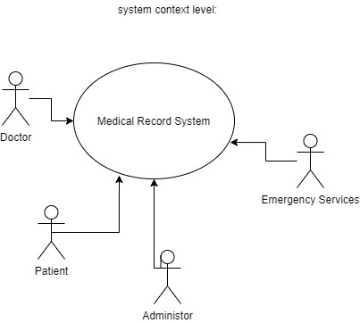 **2)  System context level:-**

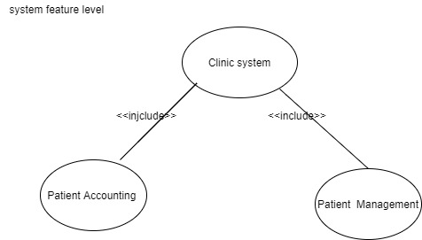 **3) System high feature level:-**

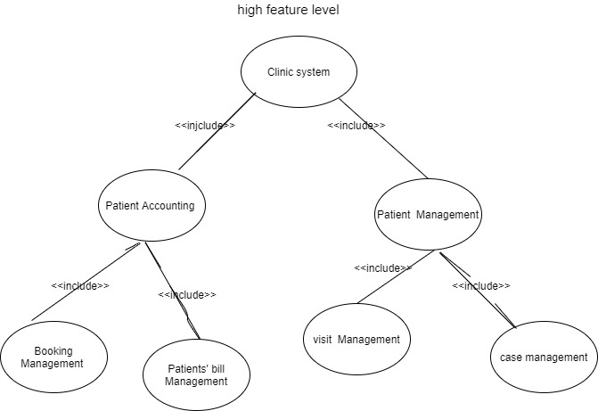 **4)  System Sub-Feature level:-**

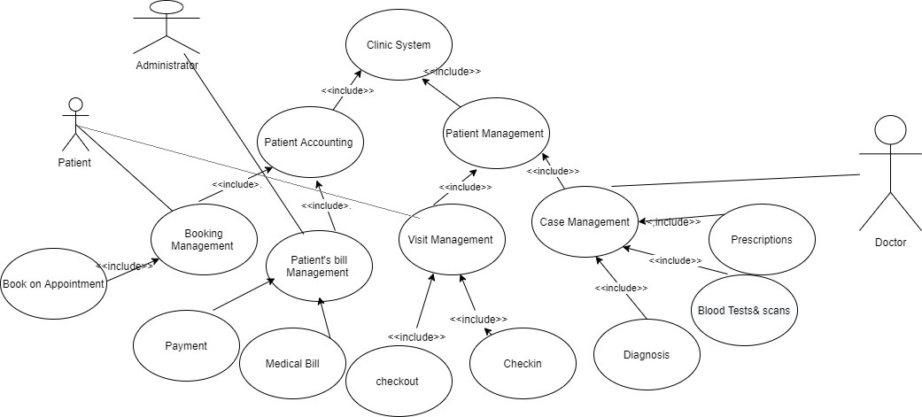 **5)  System concrete level:-**